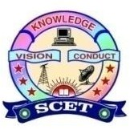

Event no: III
Title of the Activity: Idea Lab Visit
Name of the Institution
Swarnandhra College of Engineering & Technology
Name of the Scheme
AICTE IDEA Lab
Title of the Activity
IDEA Lab Visit to SRKR Engineering College
Type of Activity
Exposure Visit / Benchmarking Visit under AICTE IDEA Lab Initiative
Organizing Unit
AICTE IDEA Lab & Entrepreneurship Development Cell (EDC)
Host Institution
SRKR Engineering College, Bhimavaram, Andhra Pradesh
Date & Venue
- Date: 05/03/2025
- Venue: AICTE IDEA Lab, SRKR Engineering College, Bhimavaram
Objective of the Activity
The objective of the IDEA Lab visit was to:
- Provide exposure to best practices in the functioning of an established AICTE IDEA Lab
- Understand lab infrastructure, equipment utilization, and operational models
- Promote hands-on innovation, design thinking, and interdisciplinary learning
- Enable benchmarking for effective implementation of the AICTE IDEA Lab at Swarnandhra College of Engineering & Technology
Participants
- Faculty Coordinators of AICTE IDEA Lab
- EDC Coordinators
- Selected student innovators

Description of the Activity
As part of Event–III under the AICTE IDEA Lab initiative, a team of faculty members and students from Swarnandhra College of Engineering & Technology visited the AICTE IDEA Lab at SRKR Engineering College. The participants were briefed on the establishment, layout, equipment, safety practices, and student-centric innovation activities of the IDEA Lab. Demonstrations of tools, machines, and student-developed prototypes were showcased. The visit also included interaction with SRKR IDEA Lab coordinators regarding project execution, industry collaboration, and startup support mechanisms.
Role of AICTE IDEA Lab Initiative
- Facilitated inter-institutional learning and collaboration
- Provided insights into effective utilization of IDEA Lab infrastructure
- Encouraged adoption of best practices in innovation and prototyping
- Strengthened the roadmap for startup and incubation activities at Swarnandhra College
Outcomes of the Activity
- Improved understanding of IDEA Lab operational models
- Exposure to advanced tools and student-led innovations
- Identification of best practices for lab management and student engagement
- Enhanced motivation among students to pursue hands-on projects and startups
- Strengthened academic and innovation collaboration between institutions
Impact
The visit significantly contributed to enhancing the preparedness of Swarnandhra College of Engineering & Technology for effective implementation and utilization of the AICTE IDEA Lab. It helped bridge the gap between planning and execution by learning from a successful IDEA Lab model.
Conclusion
The IDEA Lab visit to SRKR Engineering College was a valuable exposure activity under the AICTE IDEA Lab Initiative. It aligned with the objectives of fostering innovation, experiential learning, and institutional capacity building. The insights gained from this visit will directly contribute to strengthening innovation culture, startup activities, and hands-on learning at Swarnandhra College of Engineering & Technology.

Gallery
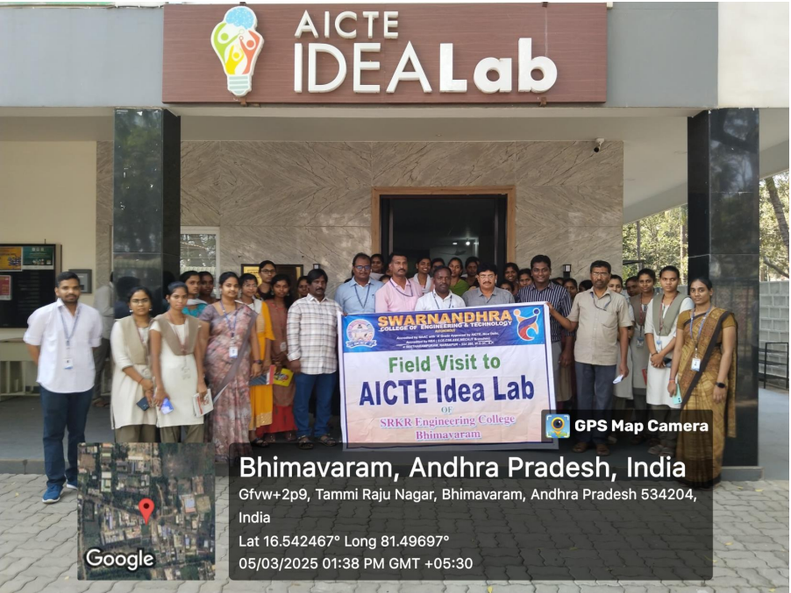 | 